Ideation Phase
Define the Problem Statements

Date | 31 January 2025
Team ID
Project Name
Maximum Marks | 2 Marks

Problem Statement :
The existing library book request process is manual and time-consuming. Students need to visit the library to request books, and librarians must maintain records manually. This makes it difficult to track requests, increases paperwork, and may lead to errors or delays in managing book requests.
To solve this problem, the Library Book Request System is developed using ServiceNow. The system provides an online book request form, validates the issue date, generates a unique request ID automatically, stores request details, and sends email notifications to the librarian. This improves efficiency, reduces manual work, and makes the book request process faster and more organized.

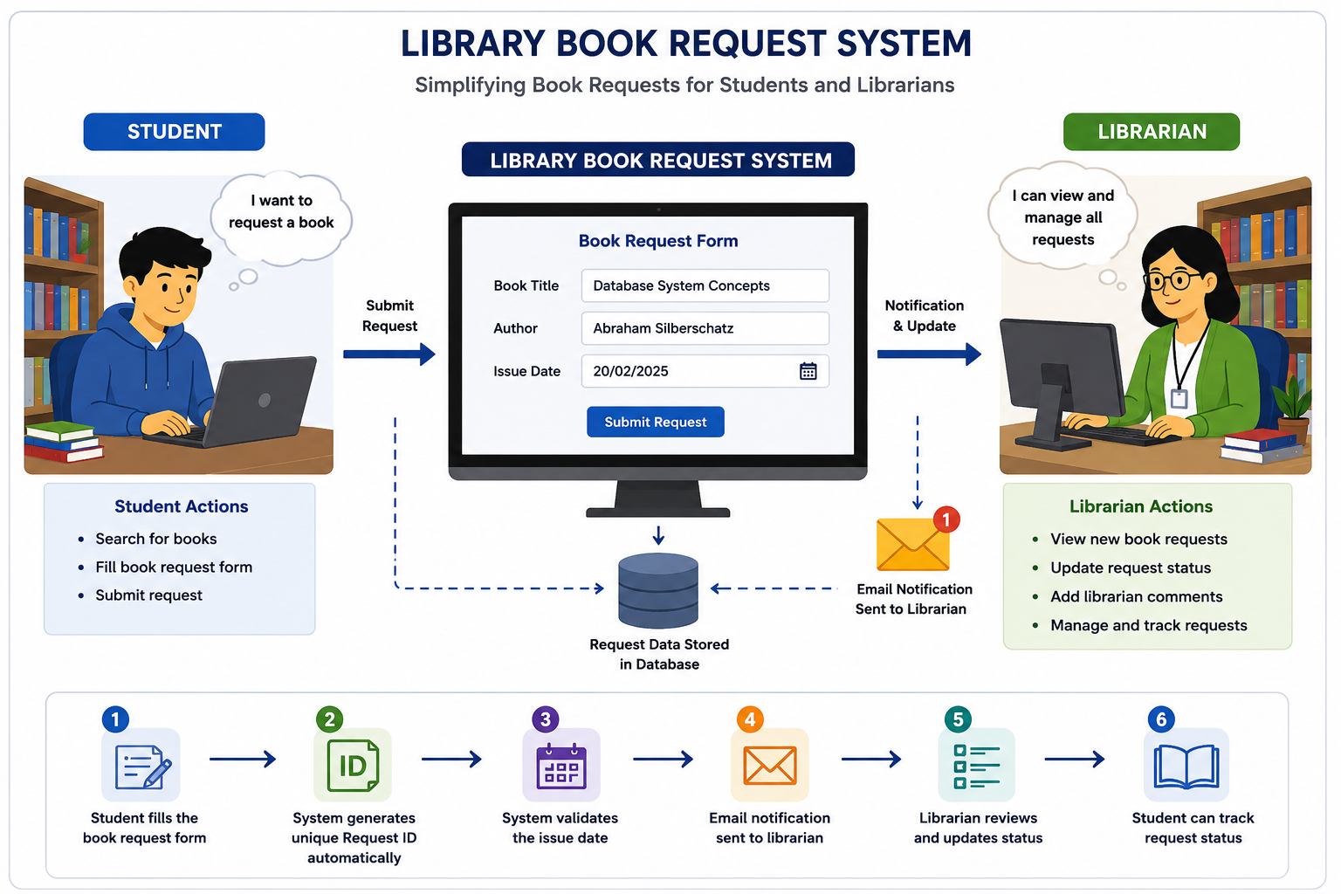

Problem  Statement (PS) | I am  (Customer) | I’m trying to | But | Because | Which makes me feel
PS-1 | A Student | Request a library book quickly | I have to submit requests manually | There is no online request system | Frustrated
PS-2 | A Librarian | Manage book requests efficiently | Requests are difficult to track | Records are maintained manually | Overloaded

